

Date: XXXXX
Prepared by: XXXXX
Subject: Fleet Size Increase Request

Increase Amount: XXXX
Vehicle Type: XXXX
Funding: XXXX
Parking Location: Lot XXXX (Must include Google map snip with precise parking location – sample below)
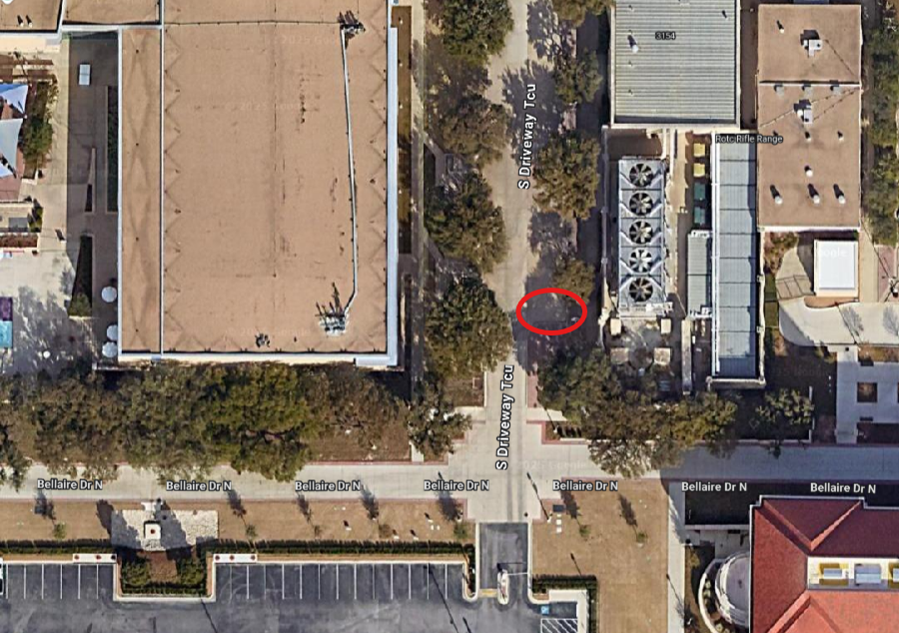

Current Fleet:
XXXXXXX

Justification:
XXXXXX

Potential Alternative Solutions to a Fleet Addition:
XXXXXX

Additional Notes (if any):
XXXXXX

