How to filter Jaggaer Requisitions
During fiscal year end, it will be very important for users to know where requisitions submitted for payment are in the approval workflow.
- For FY24 expenses submitted in Jaggaer prior to 5/31/24, requisitions must be through all SDA approvals by 5:00pm CST, 5/31/24.
- For FY24 expenses submitted in Jaggaer 6/1/24 - 6/10/24, and the fiscal year review box was checked in the requisition, requisitions must be through all SDA approvals by 5:00pm, CST 6/10/24.
It is the department’s responsibility to ensure all SDA approvals are obtained to meet the above deadlines.
In order to help identify where requisitions are in the approval workflow, Jaggaer users can filter the Requisition Orders listing to include a column identifying where the requisition is in workflow.
In Jaggaer, select Orders from the left-hand toolbar, then select Requisitions
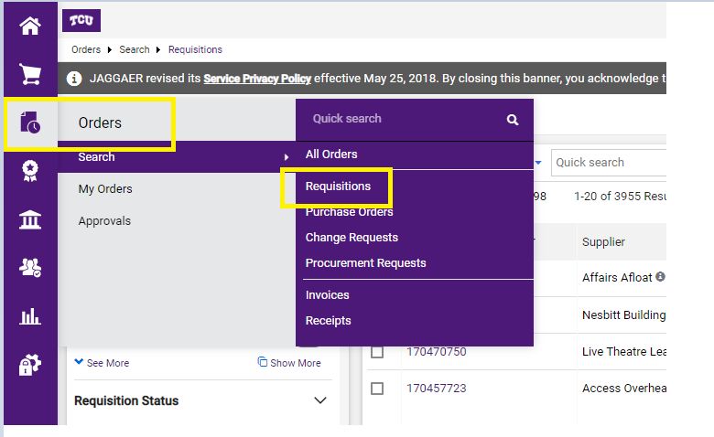
On the right side of your screen, click the settings wheel
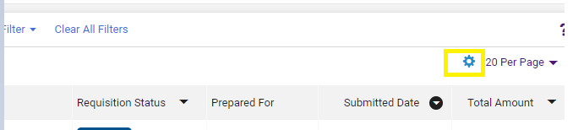
In the pop-up box, check Current Workflow Step. Once checked, it will appear on the right where you can move it up or down in the order with the arrows. Moving it up or down changes which column the information will display in the report.
You must Pin Column as my defaults, and select Apply.
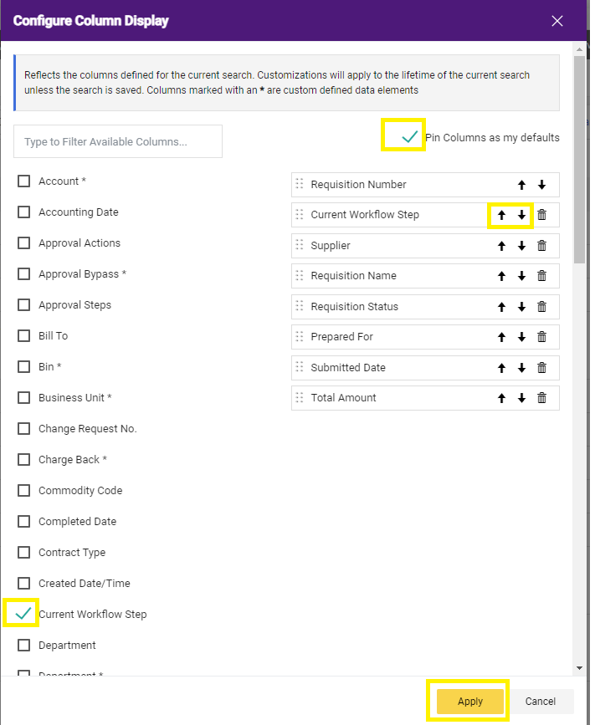
In the examples below, you can see the requisitions that are pending in blue with the current workflow step in purple. Green “Completed’ indicates the requisition has completed all SDA approvals.
Example: Hyatt Place is pending AP approval, whereas Grainger has been approved by AP, and is now awaiting approval by the Level 1 Approver.
Requisitions may be with a special approver, which is before AP’s step in the process.
Example: Automationdirect.com is awaiting Project Review, which is before AP’s step in the process.
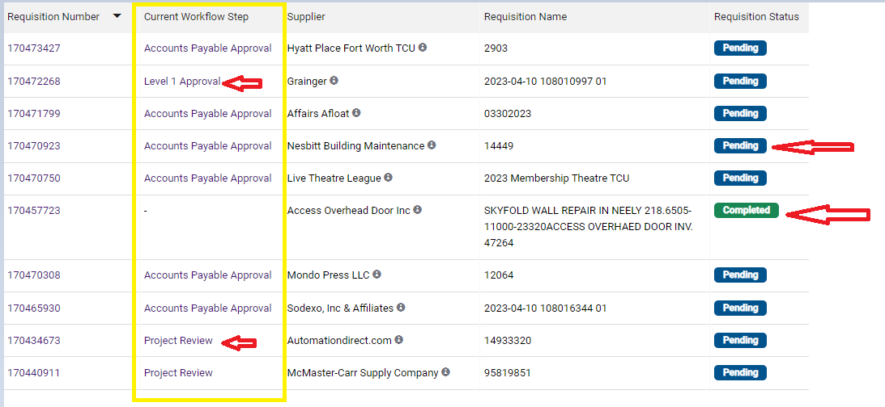
Users should click on the Requisition number to view what approvals are required.
After clicking on the requisition number, review the What’s Next section on the right-hand side of the requisition. Clicking on the Purple title of the workflow step shows who needs to approve.

Example on following page: Requisition is pending three levels of approval.
All approvals must take place by 5/31/24 to be recorded in FY24.
